The Rise of the 4th Platform: Pervasive Community, Data, Devices, and Intelligence

These days it’s still pretty common to talk about social business, mobility, analytics (especially when it’s called big data), cloud, and the Internet of Things — SMACT is the current acronym for all this — as on the agenda of key digital improvements underway in the typical enterprise. While many organizations have executed solid starts against these fronts, and are usually just at the end of the beginning overall in incorporating these technologies into their business, the majority still have a good way to go [for reasons I’ve explored recently on ZDNet](http://www.zdnet.com/article/is-it-its-last-chance-to-lead-digital-transformation/) and [elsewhere](http://www.ebizq.net/blogs/enterprise/2015/04/why_it_leaders_struggle_with_d.php).

In recent months, I’ve started to be asked what’s coming next in digital and the enterprise. While I examined the more [strategic up-and-coming technologies for the last year](http://www.zdnet.com/article/the-enterprise-technologies-to-watch-in-2014/), this doesn’t really begin to paint the strategic picture that organizations must manage to now. After all, a laundry list of technologies is just that, and won’t create results by itself. But carefully situating emerging technologies within a business in a way that truly takes advantage of their innate and unique abilities to realize value creation does, and is the essential description of the [hot topic today among CIOs and others in the C-Suite](http://adjuvi.com/the-role-of-the-cio-in-digital-and-social-business-transformation/), digital transformation.

After all, the whole point of digital transformation is realizing that technology fundamentally changes how you do business in just about every way. It therefore poses very difficult questions to business and technology leaders: Who best should do our work today? Where does the value come from? What do these new ways of working actually look like? How can we best organize to achieve them? To answer these questions, we must understand the overall narrative of our modern digital journey: Where is technology actually taking us? What is it making possible that wasn’t before? How can these possibilities give rise to uniquely valuable new types of assets that would allow us to sustain our businesses?

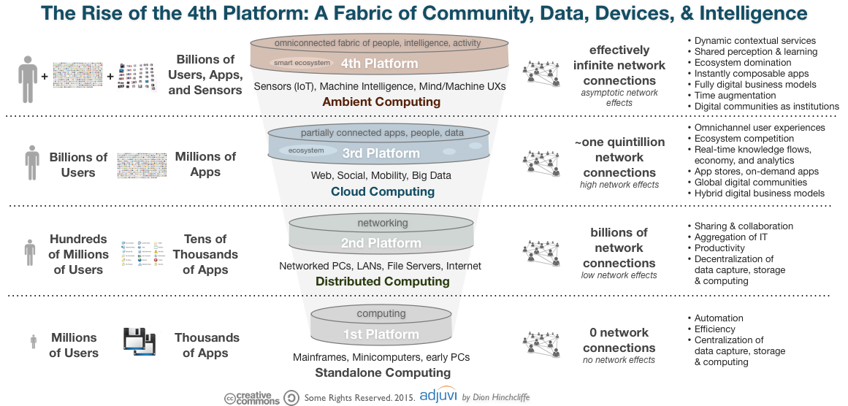

These are a lot of open questions, but we do have a sense of some of the answers now. For example, in terms of who does the work and where value comes from, we’ve learned that [the network can and will (and should) do most of it](https://dionhinchcliffe.com/2014/08/04/let-the-network-do-the-work/), if we only enable the possibilities through platforms and digital communities. The answers to other questions are more complex, though their broad outlines are becoming clear as well, such as [how can we best organize this year to achieve digital change](http://adjuvi.com/digital-priorities-for-the-c-suite-in-2015/). Why are they tough quetions? Because while digital devices and networks enable broad and reasonably well-understood realms of possibility, how precisely they apply to our industry, our business, and our corporate culture is often very different between organizations.

So when we talk about framing up the overall digital journey we are all on, the discussion is often about “computing eras”, or the emerging of new types of platforms (the cloud, for instance.) while these views are often gross simplifications, these are also useful conceptual frame-ups. Probably one of the most widely referenced view these days is IDC’s articulation of a vision [they’ve dubbed the 3rd platform](http://en.wikipedia.org/wiki/Third_platform). In the large, this view does indeed describe what’s happening, though it leaves out some of the unique flavor of what’s special about what’s happening in digital today. I’ve previously described some of the more detailed possibilities [in a view I called Web OS](http://www.zdnet.com/article/how-the-web-os-has-begun-to-reshape-it-and-business/), but this really never became a popular way of thinking about it, though it did provide the extra layer of detail many need to understand what’s happening and has held up well in my opinion.

**What’s Missing, and What’s Coming for Today’s Strategic Digital Perspectives?**

Probably the most important concept that’s almost always missing from these views [is the unique power of networks](http://www.zdnet.com/article/twenty-two-power-laws-of-the-emerging-social-economy/), especially ones made of people. One of the more remarkable is the sheer number of connections between nodes on the network that are potentially possible. Old ways of thinking about digital created largely point-to-point connections. The [advent of social media](https://dionhinchcliffe.com/2007/01/29/social-media-goes-mainstream/) made potent many-to-many network effects possible. The key word here is possible. Just because we’re connected to just about everyone in the developed world 24 hours today, doesn’t mean we actually realize that possibility. But today’s global networked platforms gives rise to the potential. In fact, for many reasons, having the ability to tap live into one’s social network is often better than having data on-hand, which is likely to be out-of-date.

So, for example, my view of what’s coming next, I don’t track the amount of data that is accumulating today. That is a great deal and growing rapidly by every account. But data isn’t useful until it’s needed, instead the ability to produce whatever is needed, when it is in fact needed, has far more ultimate value. So in my view, it’s key to understanding the strategic business nature of digital networks. This is [a key point that John Hagel wisely made in a recent entry](http://dupress.com/articles/platform-strategy-new-level-business-trends/?id=us:2sm:3tw:dup1051:eng:cons:041615:jhagel:bt15:author) in his excellent Power of Platforms series:

But in a world of mounting performance pressure, we should also expect a fourth form of platform to become prominent. Dynamic and demanding environments favor those who are able to learn best and fastest. Business leaders who understand this will likely increasingly seek out platforms that not only make work lighter for their participants, but also grow their knowledge, accelerate performance improvement, and hone their capabilities in the process.

The core concept here is that whoever learns fastest, wins, and those with the best platform and ecosystem around it, will have value that can be tapped into more rapidly for sustained strategic benefit. Plus, it will ensure coverage of virtually all of the[top level types of collaboration](https://dionhinchcliffe.com/2014/03/02/rethinking-work-in-the-collaborative-era/) in business today.

**What’s Next: Networks/Sensors In Everything, Machine Learning, and Us**

I’ve been speaking at conferences for the last year saying that just about every non-trivial object will be connected to our networks within 10 years, as part of the rapidly emerging [Internet of Things revolution](http://www.zdnet.com/article/is-the-internet-of-things-strategic-to-the-enterprise/). With the introduction of low power protocols like Bluetooth 4 and [ultra long-lived batteries in devices like the tiny — and terrific in my experience — Tile locator](https://www.thetileapp.com/faq" \l "Battery), I now believe it’s going to be more like five years.

It’s also clear that mobility is going to transform and essentially disappear, into us. Wearables and smartphones will very quickly quaint when everything we need can be beamed into our heads or embedded as needed. Computing devices will almost completely disappear into our personal and work objects, and even ourselves. While this is certainly as scary a topic as the loss of privacy on the Internet was to many of us a decade ago, it’s clear that our computing devices are going to vanish and meld into the backdrop, like any sufficient mature technology. In fact, thinkers like Koert van Mensvoort have suggested that [almost every technology eventually becomes naturalized](http://www.nextnature.net/2014/08/pyramid-of-technology/). This will be the case with the end-state of digital experiences as direct man/machine interfaces, which have long been in the lab and [is becoming increasingly sophisticated en route to the market](http://www.the-scientist.com/?articles.view/articleNo/41733/title/Brain-Machine-Interface-Goes-Wireless/).

Thus it won’t be long from now — as strange as it may seem today — that we can turn on the lights in our office just by thinking about it or order a product from Amazon after having an algorithm sift through the reviews for us simply by conceiving of doing so. We will reach a state of shared perception through all of our mutually connected devices and having knowledge networks consisting of our social graph, all devices, and the machine learning capabilities we trust most. In other words, collaboration with people and our machines will soon be truly frictionless.

**The Fourth Platform: Ambient, Pervasive, AI-Boosted Digital Networks**

All of this together: Networks of people in digital communities, pervasive sensors/controllers in nearly everything, and new types of truly frictionless interfaces will give rise to new types of ecosystems, including on-demand app creation services such as the now-famous [IFTTT service](https://ifttt.com/). The 3rd platforms enabled enormous commercial ecosystems such as those created by Google (especially their decentralized [AdWords](http://en.wikipedia.org/wiki/AdWords) network), Facebook, Amazon’s Cloud, Apple’s phones, iTunes and App Stores, and the list goes on. In the 4th platform, these platforms will become even more important — rightly or wrongly — and the most useful ones to us will literally become part of our mental furniture. The fourth platform is ambient computing, which strong components that turn network potential from our favorite ecosystems into data, and then data into knowledge, and make it as easy as just thinking about it. The next generation commercial ecosystems will even augment time and thought for us, even predicting what we’ll need before we figure it out ourselves.

If all of this sounds a little futuristic, it is also now all just within the realm of possibility, and so it will almost certainly happen, it’s just matter of exactly when. It also gives our organizations a clearer target to shoot for, at least if your organization considers moon shots. Because most organizations are struggling with being a digital contemporary in basic terms, much less getting ahead of the game. But [there are ways of getting there](http://www.zdnet.com/article/closing-the-gap-between-executives-and-digital-transformation/), if organizations are prepared, it just takes a vision of the future to aim for.

This document explains about the revolution of new technology – (Internet of Things/ Platform 4), relationship between new technology and business, and the necessity of understanding new technology. It also describes that man-machine technology is going to be disappeared and it is going to rise up a new platform soon, but still there would be a connection between 4th platform and 3rd platform. When it comes to business, organizations need to prepare for the digital transformation. Understanding the value of new technology in business bring lots of benefits to the organization. The knowledge is the key point that needs to be considered before transforming a system into a new platform.